OCC Cruising Information

One of the founding objectives of the OCC is “to collect information likely to be of use to members and to arrange for such information to be available to members....” Cruising Information is any information of use to someone deciding where to go cruising, or for anyone who might be planning to follow in your wake, or for those who might have to make an unscheduled stop. It includes pilotage, navigational information, local laws and bureaucracy, local customs, places to visit, diving, social and sporting opportunities and provisioning facilities.

The OCC Cruising Information service to OCC members provides advice on the sources of such information and assists those members who wish to record and publish such information. This service is now delivered via the OCC website. The purpose of this article is to show members where to find and how to post their Cruising Information.
The OCC Website provides a public section as a service to the Ocean Cruising Community at large and a section reserved for Members. Members data in the site and our data input features are protected and accessible to Members by logging in with a user name and password.The contents of each part is shown on the Home page and Members page by clicking on the Menu button on the top right of those pages. You can toggle between the sites using links shown in blue below. From the Forum to the Home page, there is a link on the left of the top margin of the Forum page.
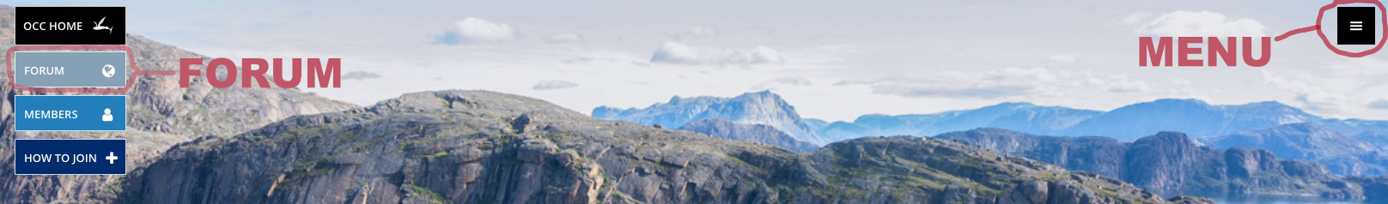
Click the Menu. This reveals, on the Public site. Pages related to Cruising Information are highlighted in yellow.

News & Events

News
Events
Awards
For Sale
Press
Gallery
Videos

About Us

The OCC
Circumnavigators
Honorary Members
Club Officers

Join the OCC

Join Online
Membership
Mentoring
Youth Sponsorship

Cruising Info

Cruising Forum
Flying Fish Archive
Publications
Cruising Info Map
OCC Fleet Map
Search OCC Website

Contact Us
Members Only Area

Access the features on the Members’ side shown below by clicking on ‘Members’ on the Home page and logging in using your OCC username and password.
(Contact the OCC Secretary if you need to obtain your username and password.)

Membership Benefits

Port Officers
Event Programme
Dockage Offered
Newsletters
Regalia - UK
Regalia - USA
Affiliated Clubs & Discounts
Interactive Map

Directories

Membership Directory
Vessel Directory
Search Members
Search Vessels
Club Officers
Circumnavigators
New Joiners
Recently Qualified
Members' Websites

My Details

Personal Details
Contact Details
Experience/Other Info
Vessel Details
Offer Dockage
Pay Subscriptions
Submit Cruising Info
Direct Debit
Membership Card
Change My Password

Reference Documents

Club Policies
Event Policies
Resources
AGM
What's New
Back to Public Website

Sources of Cruising Information:

Ask a member who is in the area or has been there:
View the OCC Fleet Map. Click on the Menu, under Cruising Info, click on OCC Fleet Map. PLEASE JOIN THE FLEET MAP. To see instructions on how to include your vessel in the OCC Fleet Map Click on the OCC Forum link on the Fleet Map page. You will see this link just above the map.

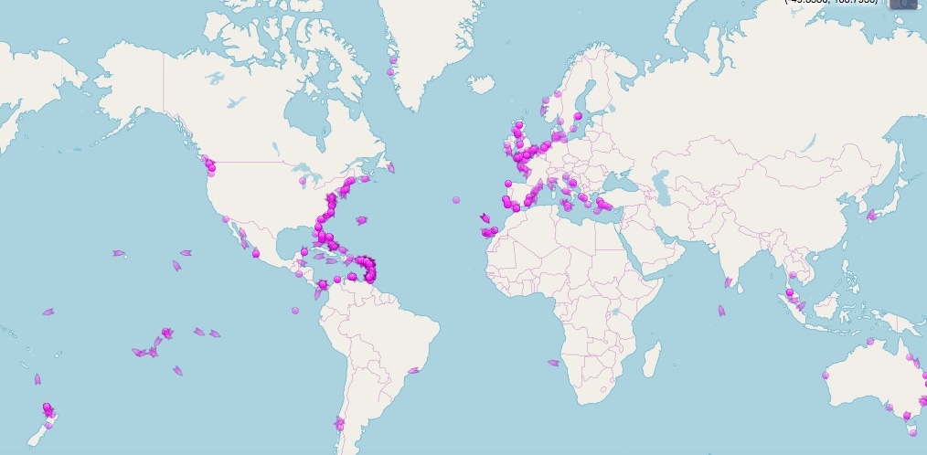

Also to find those members who have entered their experience and have been there or plan to go there: Log in to the OCC Site. Go to Search Members in the Menu; Enter in the ‘Experience’ field, your place of interest. A list of names will appear.
PLEASE COMPLETE YOUR EXPERIENCE – Log in, Menu, ‘My Details’, ‘Experience/Other Info’ Type in your experience and plans.

Printed and web based cruising guides
Many published cruising guides have been reviewed in Flying Fish. See the Public Site Menu, ‘Flying Fish Archive’, use left hand drop down box to ‘Search Archive’ Type in “Review”.

More recent reviews may be accessed via the Cruising Info map. See the Public Site, Cruising Info Map, Zoom in to your area of interest.

Web based world-wide cruising guides include:
Noonsite
Active Captain – a new site opens on May 23rd
The Pilotage Foundation
And, on line sites for specific areas such as:
Boating in Japan
Yacht Mr John, South Pacific Cruising Guides
Go West guide to Australia, Fiji, Vanuatu and New Caledonia
Yellow Flag Guide: French Polynesia

PLEASE LET US KNOW ABOUT YOUR LOCAL CRUISING GUIDES – Please post a message on the OCC Forum. Click ‘Forum’ on the Public Site, Click ‘log in’ top right of page. Select ‘Cruising Reports and Plans’ Scroll down to Select ‘Cruising Guides, Printed and On Line’. Please post the name of your guide and a short recommendation.

OCC Participation in the Pilotage Foundation.
The Pilotage Foundation publishes cruising guides across the globe, see https://www.rccpf.org.uk. The Foundation welcomes contributions from OCC members both in the form of CORRECTIONS AND UPDATES and also offers some appointments as AREA AUTHORS to OCC members. Contact info@rccpf.org.uk to discuss these opportunities.

Web based Search
Use of Web Search Engines – Google, Bing etc. To restrict the search to the OCC site Type in site:oceancruisingclub.org (space) followed by the place you are looking for (if more than one word use double quotes) e.g. site:oceancruisingclub.org Vanuatu or site:oceancruisingclub.org “South Georgia”. You can use this technique to search other sites such as members’ blogs or on line cruising guides.

The OCC Web site
Use the Site Search Engine, Menu top right of page, under Cruising Information, click on ‘Search Site’. This will look at all items on the OCC web including the Forum and Flying Fish Articles.

The Forum contains a section ‘Cruising Reports and Plans’ with sub sections for each of the major cruising areas. There is a Forum search feature top right of the page and also a log in facility. You need to log in there to POST YOUR CRUISING INFORMATION INTO THE FORUM. This method of posting is intended for longer articles covering an area cruised. The moderator will place a pointer on the Cruising Info Map at the centre of the area you describe.

The Cruising Info Map. Follow the red markers for Flying Fish reviews, the blue for posts on the forum and the yellow for member’s blog posts. Zoom in to see individual markers.

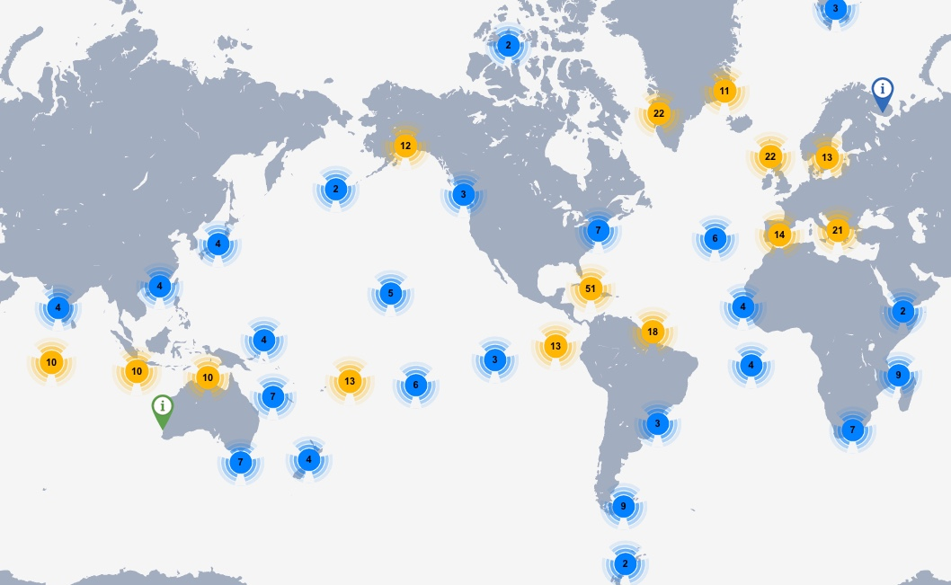

PLEASE CONTRIBUTE TO THE CRUISING INFO MAP. This method of posting is intended for shorter reports covering one place or a small area.
On the Members part of the site, under ‘My Details’ Select ‘Submit Cruising Information’. Enter a descriptive title and your text. The first 160 characters (about 30 words) of the text will appear when people click on your pointer. Zoom in on the bit of the map that relates to your post and place the pin as accurately as you can. The selected co-ordinates will now automatically display below the map window. Finally click the “Submit Information” window which will take you to the next screen, ready to submit your next report. You can find a more detailed explanation of this process on the Forum, Cruising Reports and Plans, scroll down to “New website ability to post a short report.”

The Interactive Map. This contains map based information for members only. It now shows Planned Events, Port Officers, Affiliated Clubs, Dockage Offered, Marina Discounts, Supplier Discounts. Tick the boxes beside the pointers below the map for what you want to see. This view shows Planned Events for 2018:

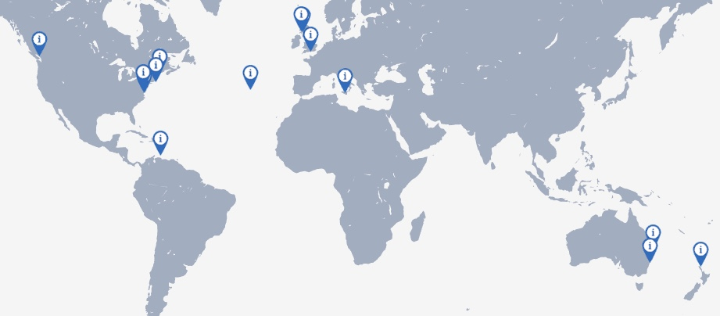

The Flying Fish Archive. This contains Flying Fish articles back to 1991 and is being extended to include the whole set back to those first published in the 1960s.
Click on menu, ‘Flying Fish Archive’ under ‘Cruising Information’. On the left hand box, you can browse this by volume, browse by cruising area or search the whole archive. ‘Browse by cruising area’ is still being worked on, so at this time, it is best to use the ‘Search’ option.

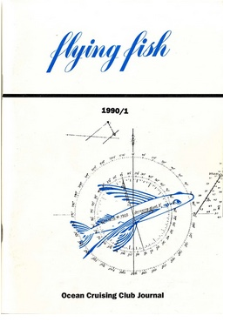
List of Members’ Web Sites and Blogs. Log in to the OCC Members section, under Directories see Members' Websites. You can take the site URL from this to use the Google ‘site:URL “Search Words”’ feature to look for specific places visited. Some links to members’ web sites will appear on the Cruising Info Map. So that members may benefit from your blog, PLEASE PUT LINKS TO YOUR BLOG PAGES FOR SPECIFIC PLACES OR AREAS INTO THE FORUM, Cruising Reports and Plans, Area Sections. Please accompany the link with a short statement of what is covered. The moderator will place a pointer on the Cruising Info Map at the centre of the area you describe.

Port Officer list. Log in Menu, click on Port Officers under Membership Benefits. To see Port Officer Information, click on the file icon under ‘Info’. The view of the Interactive Map below shows the location of OCC Port Officers.
